Car purchasing application

Design document

1. Wire Frame:

* 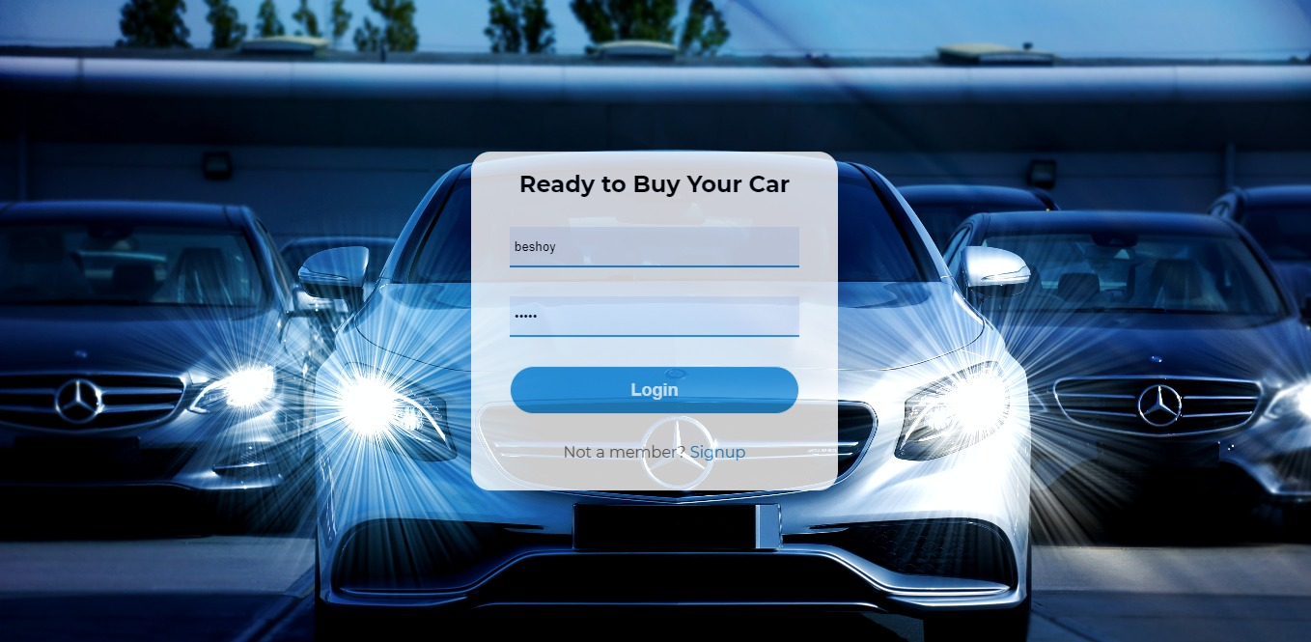Login
* Register

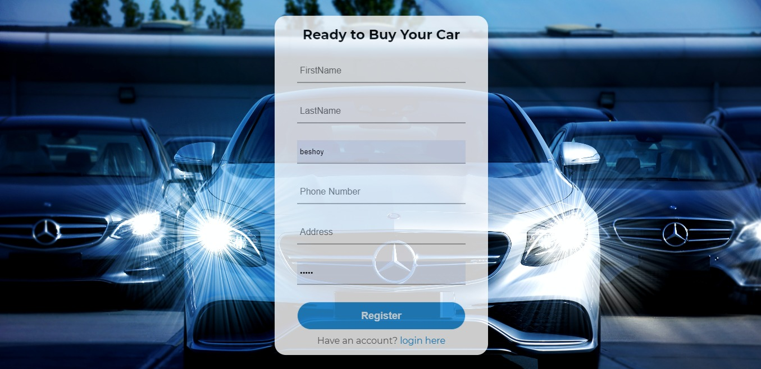

* 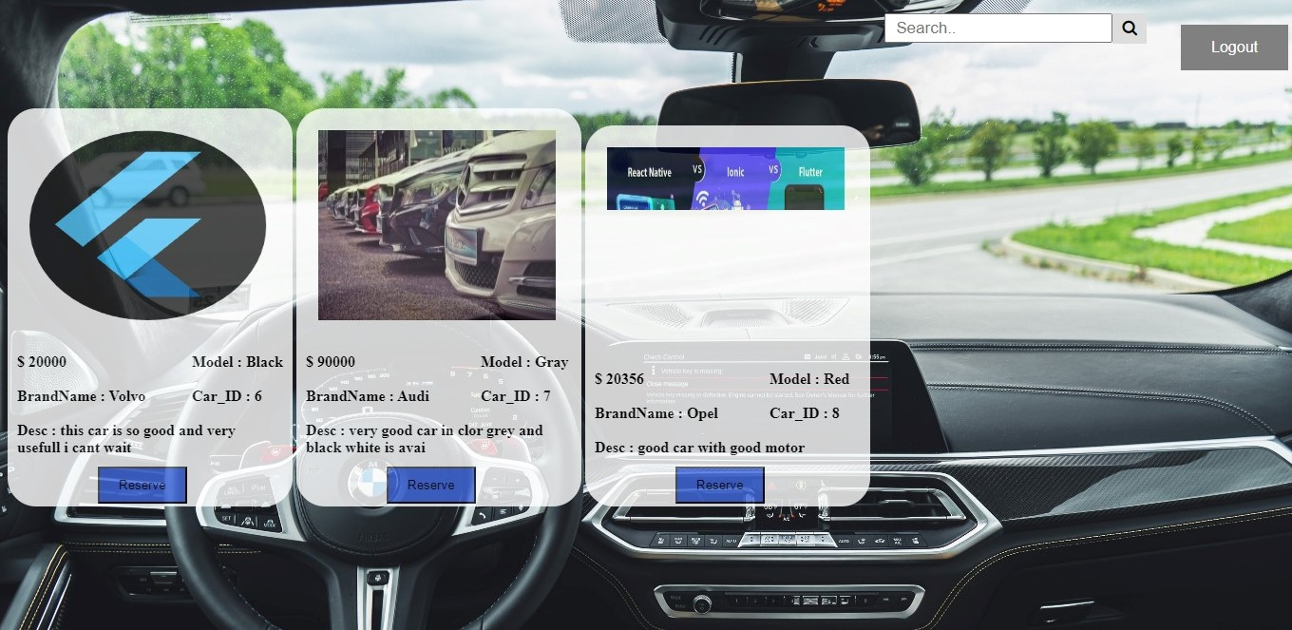Home Page
* 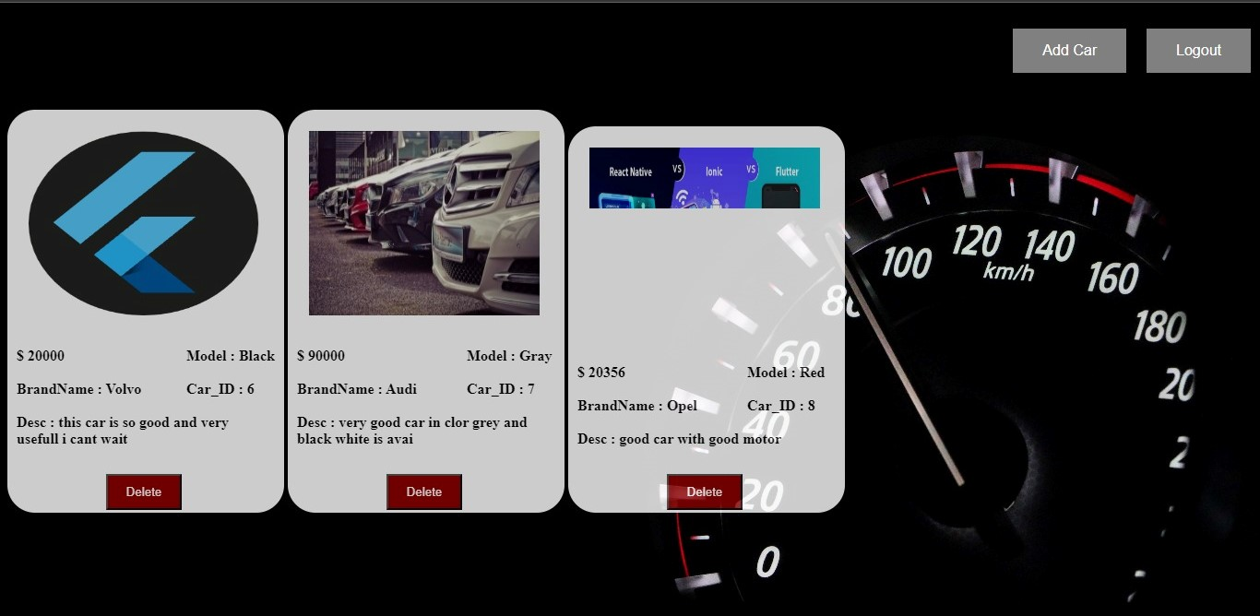Admin – Home
* 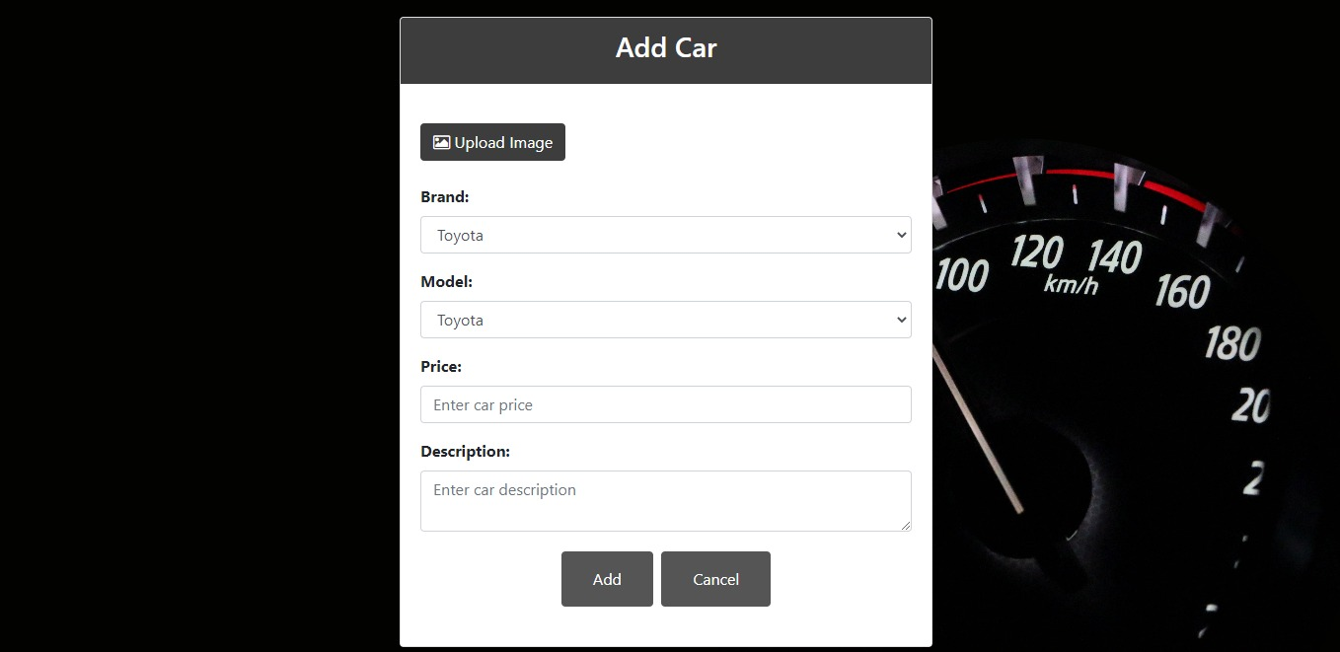Admin – add Car

2. Entity Relationship diagram

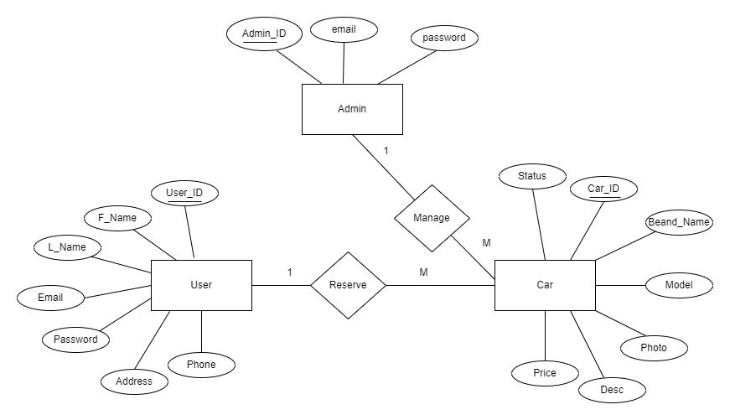

3. Use Case

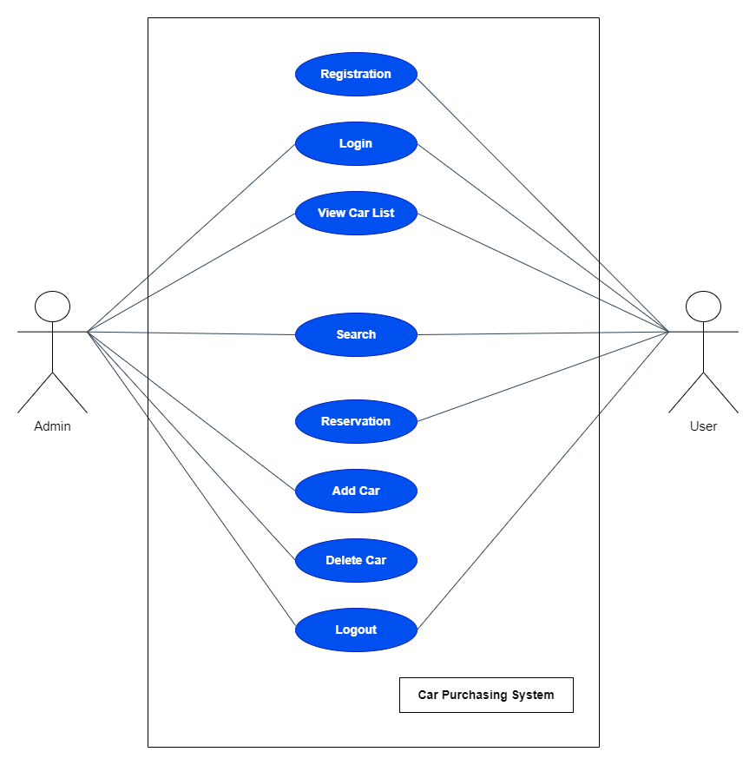

As shown in the Use Case, Admin and user have the following features:

| **Admin** | **User** |
| --- | --- |
| Login & Logout | Login & Logout |
| View car list | View car list |
| Search | Search |
| Add car | Register |
| Delete car | Reserve car |

1. Class Diagram

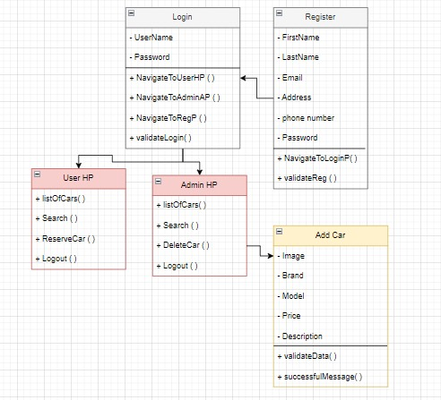

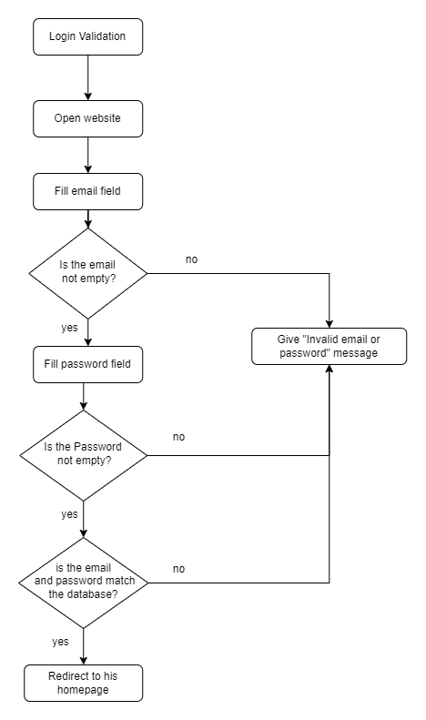5. Flow Chart

* Login

* 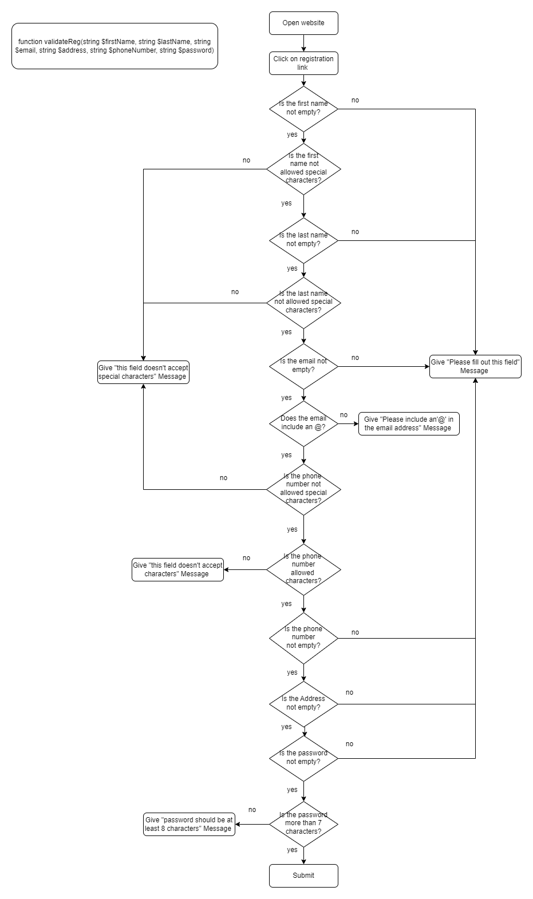Registration
* Reservation

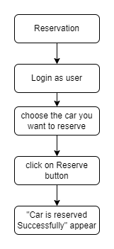

* 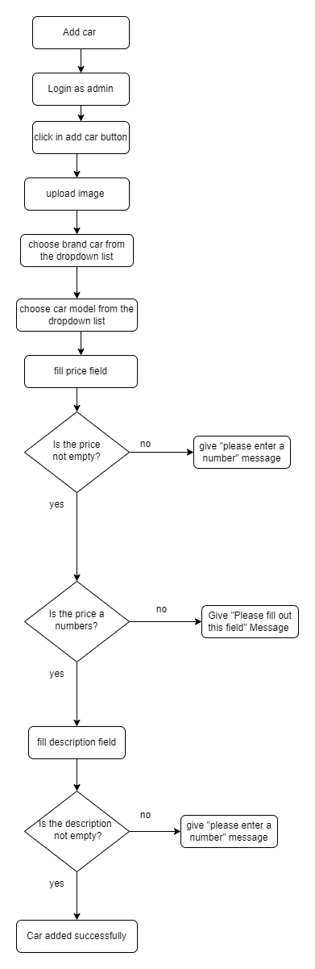Add Car
* Delete Car

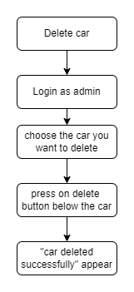

* Search

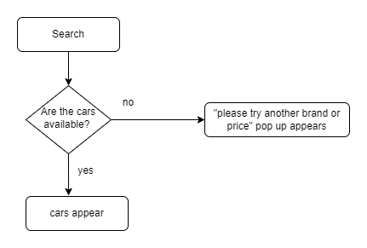

6. Sequence Diagram

User Sequence diagram

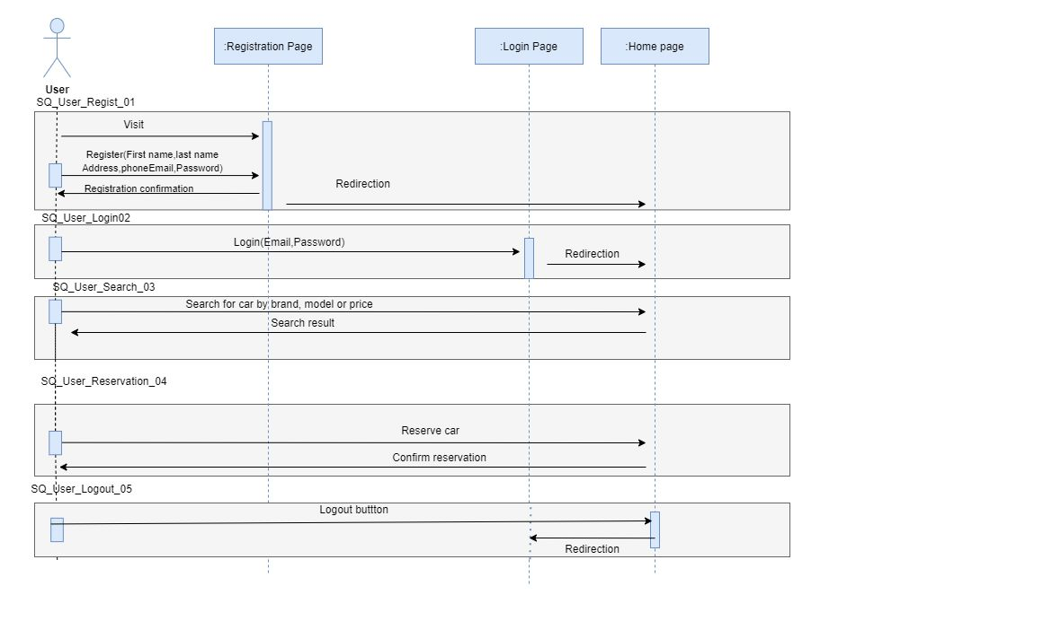

Admin Sequence diagram

